
Young Carers

In recent weeks, the children have been learning about Young Carers and the amazing lives they lead in their PSHE lessons. This is to raise awareness of Young Carers across the county but also those in our school family and community.
There are an estimated 15,000 young carers in Surrey yet only some are formally registered. Children who are young carers deserve to be recognised and children and families can access support from a variety of services.
Here at St Albans, we are committed to supporting young carers to access education. As a school community we aim to ensure young carers at St Alban’s are identified and offered appropriate support to access the education to which they are entitled.
Please see the information below and we have attached some links that you may find helpful.
If you have any queries or questions then please do not hesitate to contact the school.
Our Young Carer Champion is…
Mrs Clark

“I was a young carer from the age of 8.”
“I helped my mum who was in a wheelchair do daily chores around the house, cook, clean and helped my family look after my mum.”
“At secondary school/college I was recognised as a young carer and awarded by Surrey Youth Trust for continuing to thrive at school and still caring for my mum at home.”
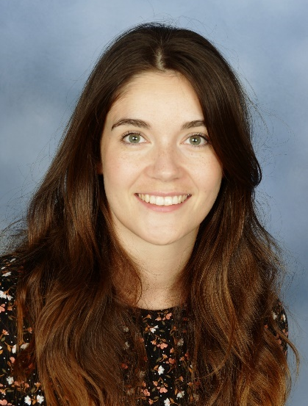

These are some of the things that were discussed in lessons:
- People who help us
- Qualities of a Young Carer
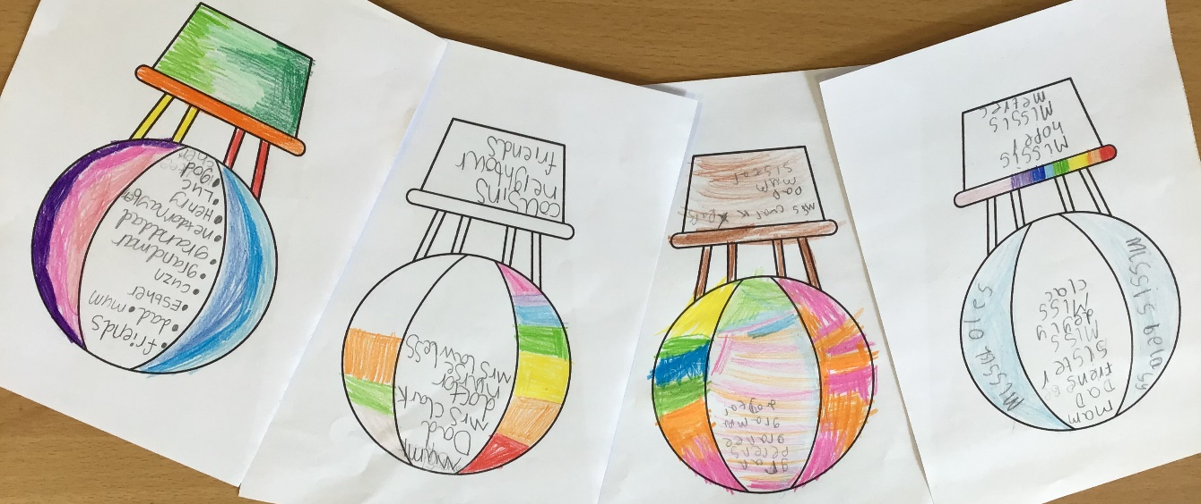
- Day to day life of a young carer.
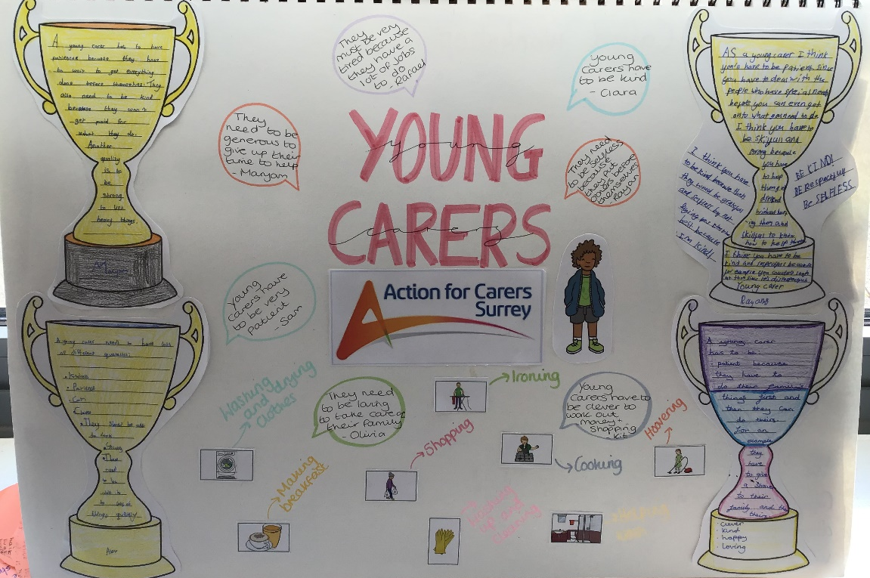

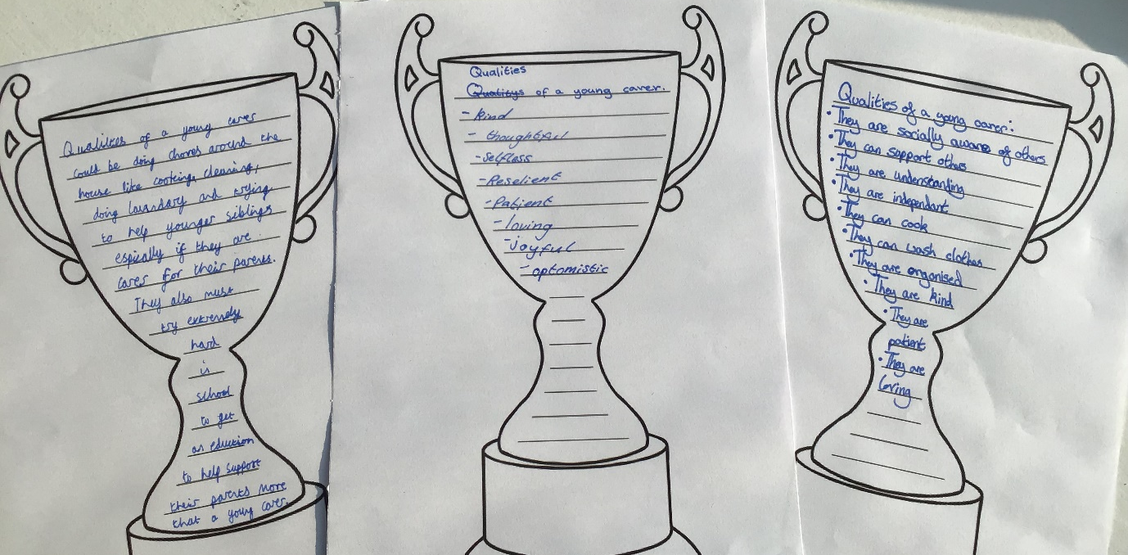

After Easter half term Young Carers will be having monthly meetings where we will discuss our own dreams and ambitions, gardening, painting and a chance to talk to other young carers and recognise that they are not alone and we can support each other.
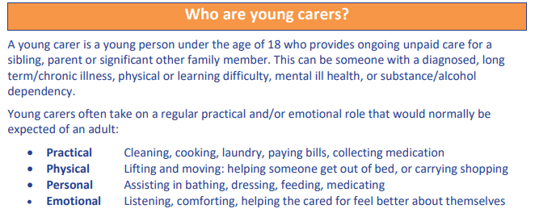
Information booklets - https://www.actionforcarers.org.uk/how-we-help/information-booklets/
Young Carers - https://www.actionforcarers.org.uk/who-we-help/young-carers-under-18/
Surrey County Council - https://www.surreycc.gov.uk/children/support-and-advice/youth-voice/cya/young-carers#:~:text=If%20you're%20under%2018,making%20meals%20or%20washing%20clothes.

